Accommodation

Language: The official language of the conference is English. The official language of the country is Romanian.
Weather: The Romanian climate is characterized by hot summers and cold winters. In November, there will be fairly hot days (above 15-18º C) and you will want to wear autumn clothes. https://weather.com/ro-RO/vreme/
Currency
The legal tender is the Romanian Leu (RON). You will be able to change your money in hotels. The approximate exchange rate is 1 EUR = 4.9310 RON.
Invitation letter/Certification of attendance: If you need official invitation to obtain visa to attend the meeting, you must register for the meeting and submit abstract. For security purposes, letters will not be sent to attendees who do not meet these requirements. Invitation letters will not be processed until you have registered and paid for the registration fees. This letters will be provided to help participants rise conference attendance funding and to obtain visas. All participants and accompanying person should have a valid passport. A certificate of attendance will be given to the registered participants upon request.
Romanian visa: http://www.mae.ro/en/node/2040
Business hours (Shops, Banks, Post offices)
Most of the shops in Craiova are open between 9:00 and 19:00 hours. During weekends, shops are open on Saturdays, between 9:00 and 14:00 hours. There are some non-stop supermarkets, too. In general, banks are open from 9.00 to 16.00 hours from Monday to Friday. Post offices open at 7.00 and close at 20.00 hours.

Hotels:
The participation fee does not include: accommodation
The organizers do not provide hotel reservations.
Please consult hotel vacancies:
Hotel EUROPECA http://www.hoteleuropeca.ro/
Tel: +40 751 224 794
Fax: +40 251 419 586
Hotel PARC http://www.hotelparc.go.ro
Tel.: +40 251 417 257
Hotel RAMADA PLAZA http://www.ramadaplazacraiova.ro/eng/
Tel. : + 40 351 100 200
Hotel BAVARIA Tel.: +40 251 414 449
http://www.hotel-bavaria.ro/
office@hotel-bavaria.ro
hotel-bavaria@yahoo.com

See you in CRAIOVA in NOVEMBER 2022 !
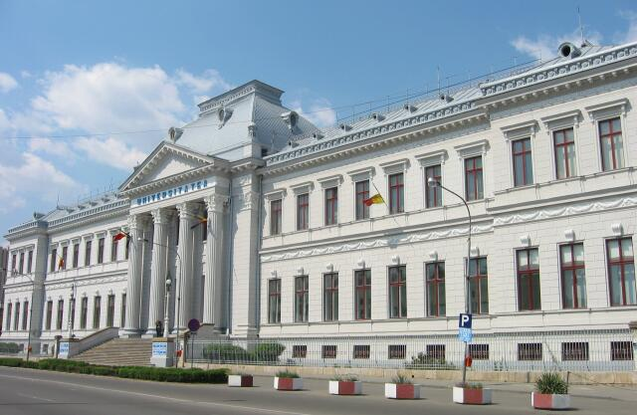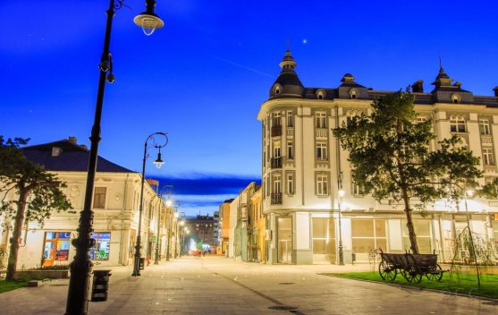
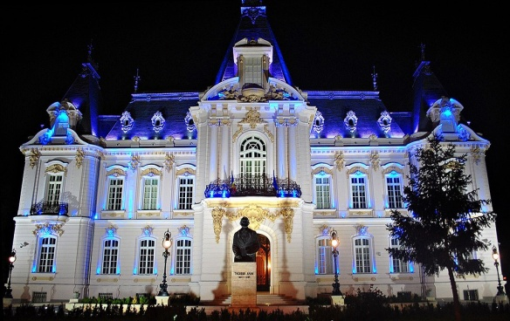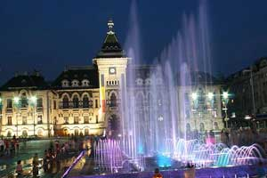
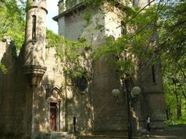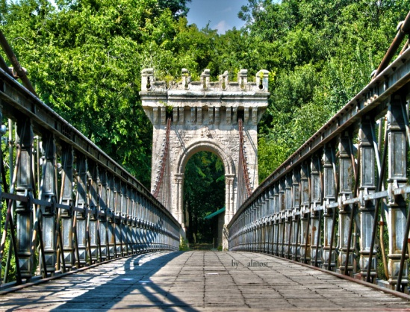
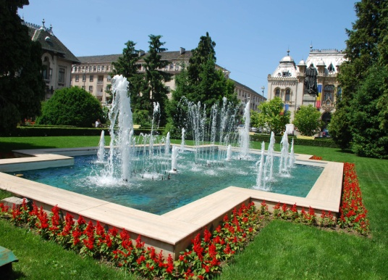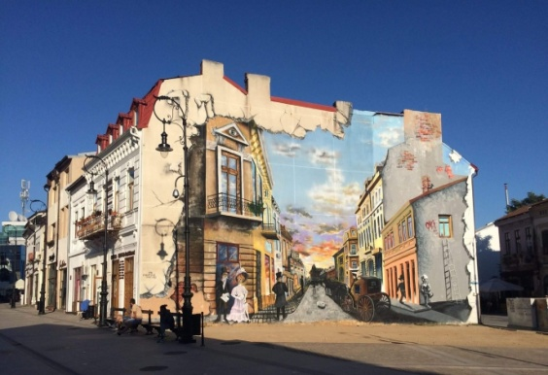
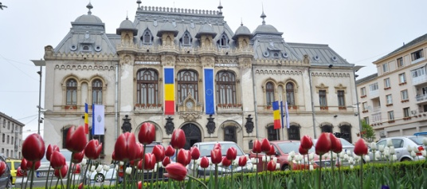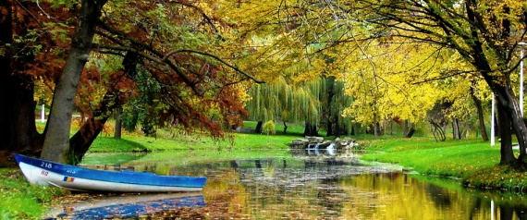
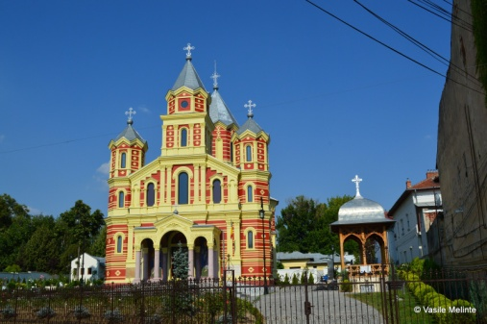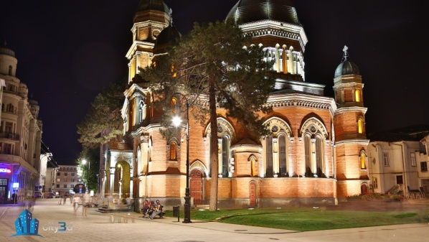
Craiova is Romania's 6th largest city and capital of Dolj County, and situated near the east bank of the river Jiu in central Oltenia. It is a longstanding political center, and is located at approximately equal distances from the Southern Carpathians (north) and the River Danube (south). Craiova is the chief commercial city west of Bucharest and the most important city of Oltenia. The city prospered as a regional trading centre despite an earthquake in 1790, a plague in 1795, and a Turkish assault in 1802 during which it was burned.

