Accommodation

Language: The official language of the conference is English. The official language of the country is Romanian.
Weather: The Romanian climate is characterized by hot summers and cold winters. In November, there will be fairly hot days (above 15-20º C) and you will want to wear autumn clothes. https://weather.com/ro-RO/vreme/
Currency
The legal tender is the Romanian Leu (RON). You will be able to change your money in hotels. The approximate exchange rate is 1 EUR = 4.9310 RON.
Invitation letter/Certification of attendance: If you need official invitation to obtain visa to attend the meeting, you must register for the meeting and submit abstract. For security purposes, letters will not be sent to attendees who do not meet these requirements. Invitation letters will not be processed until you have registered and paid for the registration fees. This letters will be provided to help participants rise conference attendance funding and to obtain visas. All participants and accompanying person should have a valid passport. A certificate of attendance will be given to the registered participants upon request.
Romanian visa: http://www.mae.ro/en/node/2040
Business hours (Shops, Banks, Post offices)
Most of the shops in Craiova are open between 9:00 and 19:00 hours. During weekends, shops are open on Saturdays, between 9:00 and 14:00 hours. There are some non-stop supermarkets, too. In general, banks are open from 9.00 to 16.00 hours from Monday to Friday. Post offices open at 7.00 and close at 20.00 hours.

Hotels:
The participation fee does not include: accommodation
The organizers do not provide hotel reservations.
Please consult hotel vacancies:

Hotel PARC | http://www.hotelparc.go.ro  Tel.: +40 251 417 257
Hotel EUROPECA | http://www.hoteleuropeca.ro/  Tel: +40 751 224 794  Fax: +40 251 419 586
Hotel RAMADA PLAZA | http://www.ramadaplazacraiova.ro/eng/  Tel. : + 40 351 100 200
Hotel BAVARIA | http://www.hotel-bavaria.ro/  office@hotel-bavaria.ro  hotel-bavaria@yahoo.com  Tel.: +40 251 414 449

See you in CRAIOVA in NOVEMBER 2023 !
Craiova is Romania's 6th largest city and capital of Dolj County, and situated near the east bank of the river Jiu in central Oltenia. It is a longstanding political center, and is located at approximately equal distances from the Southern Carpathians (north) and the River Danube (south). Craiova is the chief commercial city west of Bucharest and the most important city of Oltenia. The city prospered as a regional trading centre despite an earthquake in 1790, a plague in 1795, and a Turkish assault in 1802 during which it was burned.
Tourist Objectives in Craiova

• The oldest construction in Craiova which was kept as testimonial is Coșuna Monastery - Older Bucovat, but from all the initial ensemble, only the church is preserved today. Even if the stone inscription indicates the following date: 3 of December 1572, an older cartography sustains that the monastery was built 1483. In terms of architectural style, the church was built in mountainous style, characterized by the synthesis of popular autochthon elements and Byzantine elements. | 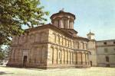
• "Jitianu" Monastery, is considered the foundation of Serban Voievod (1654-1658). Churches in Brancovenesc style: Saint Ilie – built in 1720 by the boyar Ilie Oteteliseanu and the higher chapmen of the city (painted by the artist C. Lecca, between 1840-1841, restored in 1893, the actual painting being the one executed by Ghe. Ioanid and Ghe. Tatarescu), Church of all Saints (1700), Old St. Gheorghe Church (1730), Monastery Obedeanu (1747), Church Mantuleasa (1786), Church Saint Nicolae (1794). | 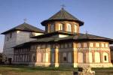
• The Metropolitan Bishopric of Oltenia, was built by Matei Basarab in 1652. Affected by the earthquake from 1840, the church was closed until 1889, when the restoration work began under the leadership of the architect Andre Lecomte de Nouy which built from the groundwork the actual construction, without complying with the old style. | 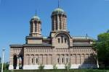
• Baniei’s Home, the oldest building which exists today in the city, dating from 1699. Restored by Constantin Brancoveanu, Baniei’s Home has two levels, with rooms with bolts of brick, with rooms and thresholds upstairs. Was built by old handed architects of the regnant, in a popular style. Here used to be held Craiova’s divan, and in the time of Austrian occupation it was the residence for the prevailfogs. After this the building was successive: for Murtaza Pasa (1737-1739), private home for the bishop, first local school in Craiova (1750), premise for the High Court, local school - Gymnasium Brothers Buzesti (1896-1914) and normal school of mistresses, premise for Oltenia’ Museum (1934-1948) and for the ward of ethnography (from 1967). | 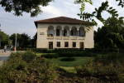
• "Jean Mihail" Palace (the actual Museum of Art), is located in the sumptuous palace of the former magnate Jean Mihail. Built between 1899-1907, according to the plans of the French Paul Gottereau, the palace represents, stylistically, a rather free interpretation of the late baroque. | 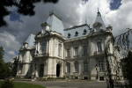
• Vorvorenilor’s Home – present residence of the Oltenia’s Metropolitan – is a palace built after the plans of the architect D. Maimarolu; he presents the late influence of the French Renaissance, characterized by attic roofs, a multitude of ornaments and richly decorated interiors. | 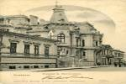
• The University - the former Palace of Justice, was designed in 1890 by the architect Ion Socolescu and it is an illustration of the neoclassicism in architecture. | 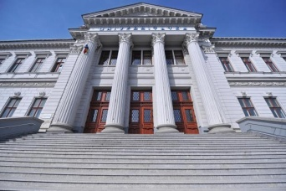
• Another distinct construction is the former Bank of Commerce, now City Hall of Craiova. Designed by the architect Ion Mincu, was finished in 1916 by his student or Constantin Iotzu. The building has a rich decorated interior, with set off ornaments, stained glasses, Venetian mosaic and lattices from cast iron. | 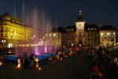
• An interesting, vigorous construction with architectonical, popular characters is the former Administrative Palace, today headquarters for the Prefecture and the Council of Dolj. Creation of the architect Petre Antonescu this building was realized between 1912-1913. | 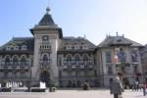
• After the 1-st World War, on stylistic plan remains the by affirmation of the national elements in art. In Craiova of this period was built so-called White House (on one side of the central garden – English Park – realized in London square style), after the plans of the architect Constantin Iotzu. From the contemporary achievements we have to mention the new edifice of the National Theatre inaugurated in 1973. | 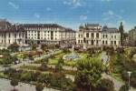
• Another attraction point of Craiova is "Nicolae Romanescu" Park, unique in Romania and one of the most interesting achievements of this type from Europe. The project, creation of the French architect E. Redont, received the Gold Medal at the International Exhibition from the Paris, in 1900. The total area of the park consists in over 96 ha of plantation (trees, lawns, shrubs), a stretch of water of 4 ha, a racecourse of over 20 ha, roads, avenues and pathways on a stretch of 35 km. There is also a zoo, where it can be seen especially species of birds, autochthon animals and foreign also. | 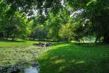
• Botanical Garden was arranged by the initiative of Al. Buia, in order to serve as a study base for the students from the faculties of Agronomy and Horticulture as well as recreation area. The garden has an area of 17 ha and is bordered on distinct sectors: ornamental (about 4.5 ha), systematically, the globe’s flora, economically. | 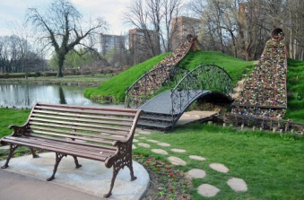
The "Marin Sorescu" National Theatre  The Marin Sorescu National Theatre occupies a special place in the history of the Romanian theatre. Founded in 1850 by Costache Caragiale and Costache Mihailescu, it continued to function, in spite of all the convulsions characterizing the history of our nation. | 